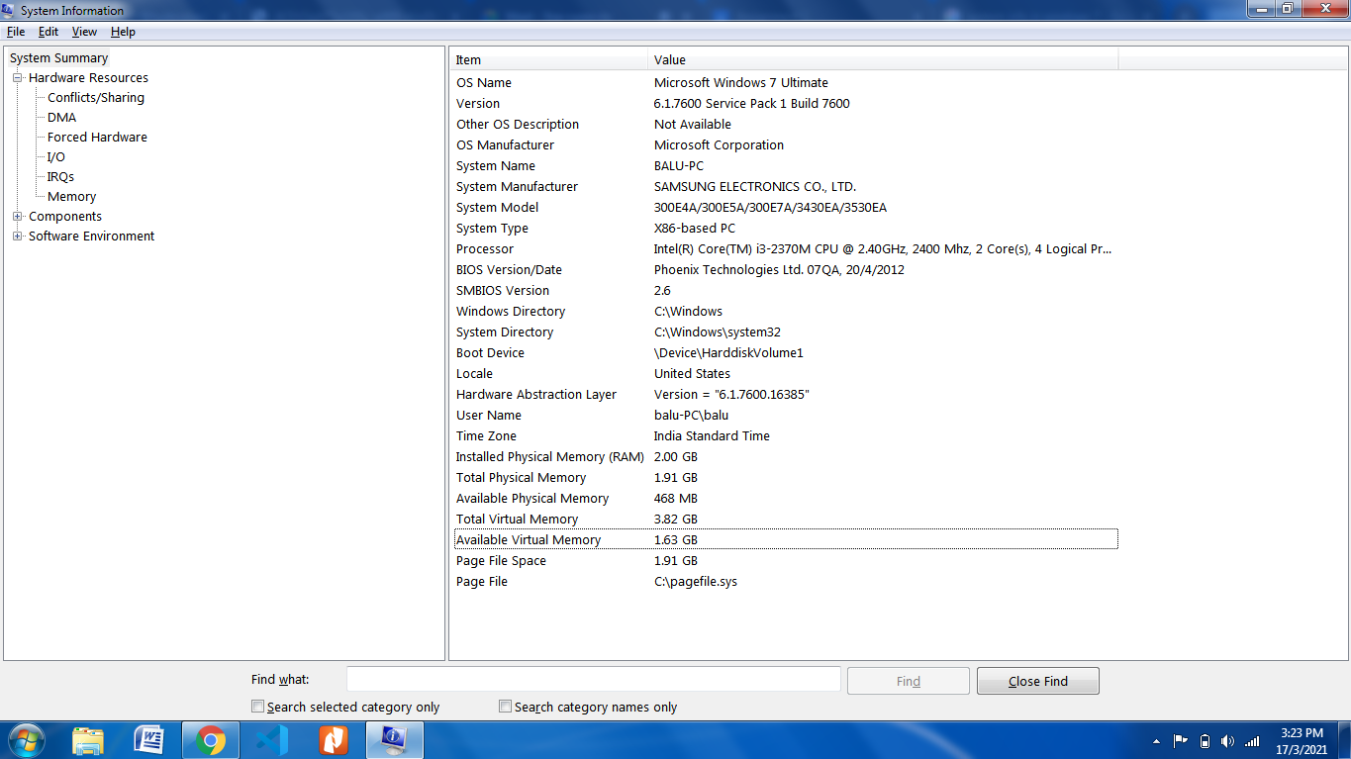

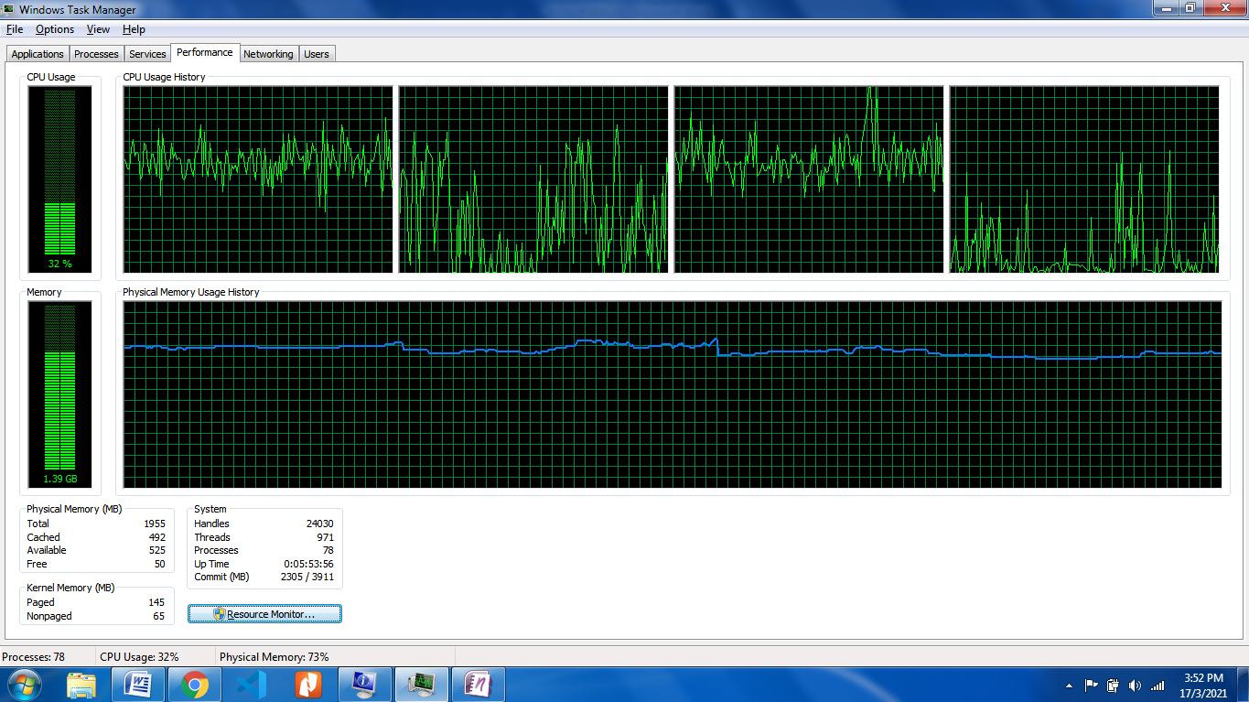

The above screenshot has both CPU (Green graph) and Memory (Blue graph).

Answers to MCQs

1. C
2. C
3. A
4. C
5. C

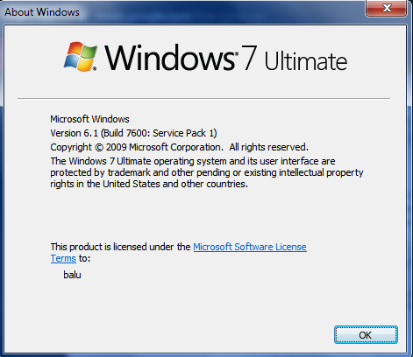

Answer to question

1. Application
2. System
3. Application

Answers to Assignment

1. 3
2. 4
3. 3
4. 2
5. 1
6. 1
7. 2
8. 4
9. 3
10. 3
11. 3